Legacy (non-SFRA) SpeedFlex



## Table of Contents

Table of Contents 2

Setup 3

Configuration 6

Setting Up Your Site 6

Initial Setup and General Settings 7

Set up Search Settings (Optional) 21

Installation & Code 27

Global Includes 28

Product Detail Page 28

Category and Search Pages 30

Other Features 33

Testing Use Cases 40

Q&A Testing 41

Reviews Testing 41

Refinements Testing 44

Checkout Comments 44

Javascript Order Feed Testing 45

## Setup

**IMPORTANT NOTE: This document contains the integrating instructions for non-SFRA architecture only using either controllers or pipelines. Please refer to the SFRA document for a complete SFRA installation. Please NOTE that pipelines are not officially supported in the updated cartridge.**

***IMPORTANT NOTE: This document is for SpeedFlex only, for older installations please refer to version 4.3***

#### Architecture Overview

This TurnTo® LINK integration contains one cartridge, named int_turnto_core_v5. SpeedFlex uses significantly less code on the SFCC side and most configurations are now handled within the TurnTo dashboard and rendered via the widgets JavaScript file included in the TurnTo header.

#### Localization

The cartridge supports localization for all jobs. Each job will loop through all locales declared in BM custom preference in site key for the current job scoped site. An SFCC site and product catalog supports multiple locales per instance and are mapped to multiple distinct TurnTo sites, each with their own configuration and one locale per site.

**IMPORTANT NOTE: “default” locale is not allowed.**

#### Export and Import Jobs

The int_turnto_core_v5 contains the TurnTo entry points, which contain a JS script that is used for jobs.

##### ExportHistoricalOrders

The ExportHistoricalOrders entry point exports all customer orders that have been placed in the last X days (this number is configurable via site preference). The exported data is then automatically pushed to the TurnTo® system via HTTP. A temporary file, named “exportOrders.txt”, is written to a TurnTo folder within the Import/Export folder

Example: “[your_sandbox_url]/Impex/TurnTo/[locale]/exportOrders.txt”

The file is left on the files system after the job is finished. The file is overwritten each time the export job is run.

##### ExportHistoricalOrdersByDate

The ExportHistoricalOrdersByDate entry point exports all customer orders that have been placed on X date (this date is configurable via site preference). This job is designed to be manually run in the event that order(s) from a specific date were not uploaded successfully in the past. The exported data is then automatically pushed to the TurnTo® system via HTTP. A temporary file, named “exportOrder.txt”, is written to a TurnTo folder within the Import/Export folder.

Example: “[your_sandbox_url]/Impex/TurnTo/[locale]/exportOrders.txt”

The file is left on the files system after the job is finished. The file is overwritten each time the export job is run.

##### ExportCatalog

The ExportCatalog entry point exports all of the products from the catalog. The exported data is then automatically pushed to the TurnTo® system. A temporary file, named “exportCatalog.txt”, is created in a TurnTo folder within the Import/Export folder.

Example: “[your_sandbox_url]/Impex/TurnTo/[/[locale_with_same_site_key]/exportCatalog.txt”

The file is left on the files system after the job is finished. The file is overwritten each time the export job is run.

##### ImportAverageRatings

The ImportAverageRatings entry point imports all of the average star ratings for your product SKUs from the SKU-to-Average Star Rating Feed. This data is only used for attribute refinements on pages such as search results and category landing.

All data is reset before the import.

**NOTE: You will need to contact your TurnTo® support representative to enable this feed.**

##### ImportUserGeneratedContent

The ImportUserGeneratedContent entry point imports all of the user-generated content (Questions, Answers, Replies, Comments, and Reviews) for all items on your site, and stores it in a searchable attribute on the product data.

All data is reset before the import.

**NOTE: You will need to contact your TurnTo® support representative to enable the XML version of this feed.**

NOTE: The update feeds run by attempting to process all products in the incoming file. If there are problems updating any of the product records due to locking or database availability the offending SKU will be logged to the job log file and the job will continue processing the next products. If at least one product level error occurred the job will complete but in a “ERROR” state. In this case the job logs should be examined to determine the impacted product ids. This may require the job to be manually run at a time when the resources are available.

Logger.error('Product SKU {0} failed to update due to {1}', product.ID, e.message);

The log files can be found in Business Manager here: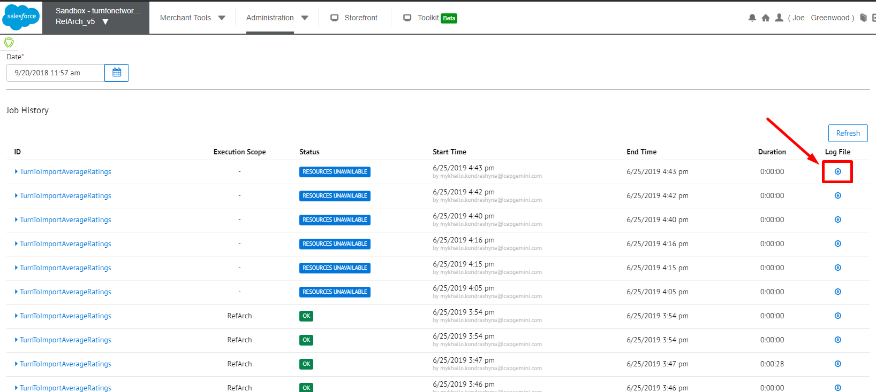

## Configuration

### Setting Up Your Site

1. Create a TurnTo account on [www.turnto.com/register](http://www.turnto.com/register) if you don't already have one.
2. Make sure your TurnTo contact has added your site to the [turnto.com](http://turnto.com/) system.
3. Make sure your TurnTo contact has made you a TurnTo account manager of your site. Once you are a manager of your site, you will see a new navigation area on the left with your site name and links to your settings, reporting and moderation.
4. Add cartridges to site cartridge path
   1. In Business Manager, Click Sites in the Administration section
   2. Click "Manage Sites" link
   3. Click the name of your site. For instance, SiteGenesis.
   4. Click the "Settings" tab.
   5. Using legacy architecture, fill in the cartridge field with the following as: int_turnto_core_v5:[site_siteid]:storefront_controllers:storefront_core

**NOTE: replace cartridges in brackets with your site level and base cartridges.**

* 1. Click Apply

1. The import/export jobs require the use of the SFCC job components cartridge, which has a cartridge name “bc_job_components”. This will need to be downloaded from the SFCC repo and added to your workspace.

SFCC repo -> <https://github.com/SalesforceCommerceCloud/job-components>

*If you do not have access to the above link, you will need to submit an SFCC ticket to gain access

1. Add cartridges to business manager cartridge path
   1. In Business Manager, Click Sites in the Administration section
   2. Click "Manage Sites" link
   3. Click the "Business Manager" link
   4. Using legacy architecture, fill in the cartridge field with the following as:
   5. int_turnto_core_v5:bc_job_components  
      **NOTE: bc_job_components will need to be added, see Step 5 above.**
   6. Click Apply

### Initial Setup and General Settings

#### Upload and Import Metadata

1. In Business Manager, click "Site Development" in the Administration section
2. Click "Import & Export" and then, under the section Import & Export Files, click "Upload"
3. Choose the file located in *metadata/TurnToMetaData_v5.xml* and click "Upload"
4. Return back to the "Import & Export" page, and then, under Meta Data, click "Import"
5. Select the file you just uploaded, and click "Next". Once the file validates, click "Import"

#### Upload and Import Job Schedules

1. Open the file *metadata/TurnToJobSchedules_v5.xml*, and edit it.
2. Modify all references to site-id="SiteGenesis" in the file, replacing them with the ID of your site
3. In Business Manager, click "Operations" in the Administration section
4. Click "Import & Export" and then, under the section Import & Export Files, click "Upload"
5. Choose the file you just edited, and click "Upload"
6. Return back to the "Import & Export" page, and then, under Job Schedules, click "Import"
7. Select the file you just uploaded, and click "Next". Once the file validates, click "Import"

#### Upload and Import Services

1. In Business Manager, click "Operations" in the Administration section
2. Click "Import & Export" and then, under the section Import & Export Files, click "Upload"
3. Choose the file located in *metadata/TurnToServices_v5.xml* and click "Upload"
4. Return back to the "Import & Export" page, and then, under Services, click "Import"
5. Select the file you just uploaded, and click "Next". Once the file validates, click "Import"

#### TurnTo General Settings

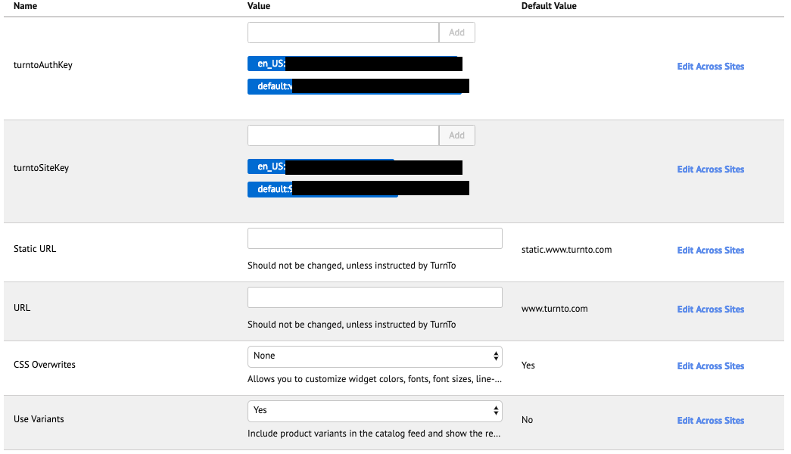

**NOTE: Notice localized variables auth and site key and mobile landing title.**

1. In Business Manager, click "Custom Preferences" in the Merchant Tools section, under Site Preferences
2. Click on "TurnTo General Settings" and then fill out the following information (* means required):
   1. Auth Key*: <YOUR AUTH KEY> (Your Auth Key will be provided by your TurnTo Customer Success Manager) Must be in the following format -> [locale]:[auth_key]
   2. Site Key*: <YOUR SITE KEY> (Your Site Key will be provided by your TurnTo Customer Success Manager) Must be in the following format -> [locale]:[site_key]:[domain]
   3. Static URL: default is "[static.www.turnto.com](http://static.www.turnto.com/)" (**NOTE: no http:// or https:// or trailing slashes**)
   4. URL: default is "[www.turnto.com](http://www.turnto.com/)" (**NOTE: no http:// or https:// or trailing slashes**)
   5. Use Variants – Set to ‘Yes’ to include product variants in the catalog feed and show the reviews for individual variants on the product details page. Reviews for other variants will be shown as related reviews. Default is ‘No’
3. Click Apply

#### TurnTo Javascript Feed

Purpose: Collects real-time order data on the order confirmation page

1. In Business Manager, click "Custom Preferences" in the Merchant Tools section, under Site Preferences
2. Click on "TurnTo Feeds" and then fill out the following information:  
   Javascript Feed (on Order Confirmation): "Yes" if you want to enable the collection of real-time order data on the order confirmation page, "No" otherwise
3. Click Apply

#### TurnTo Catalog Export Feed



Purpose: Generates a catalog feed in the TurnTo format and uploads it to [turnto.com](http://turnto.com/) via HTTP for processing.

The catalog export feed is localized and may contain multiple feeds if more than one site level locale is enabled.

**NOTE: The catalog feed includes links to product images. By default, the image store is used. If you use a third party to store your images you’ll need to modify ExportCatalog.js in the int_turnto_core_v5 cartridge to point to your image store.**

1. Login to your Business Manager account
2. Click the Operations link in the Administration section
3. Click Job Schedules
4. Click "TurnToCatalogExport”
5. Configure your desired run frequency, as well as any notifications, and make sure "Enabled" is checked.
6. Verify the steps in the “Step Configurator” are set to the correct site
7. Click Apply
8. Recommendation: Run this job schedule once manually, to perform the initial load of your product catalog into the TurnTo system
9. Recommendation: Configure error handling for your email address for testing.

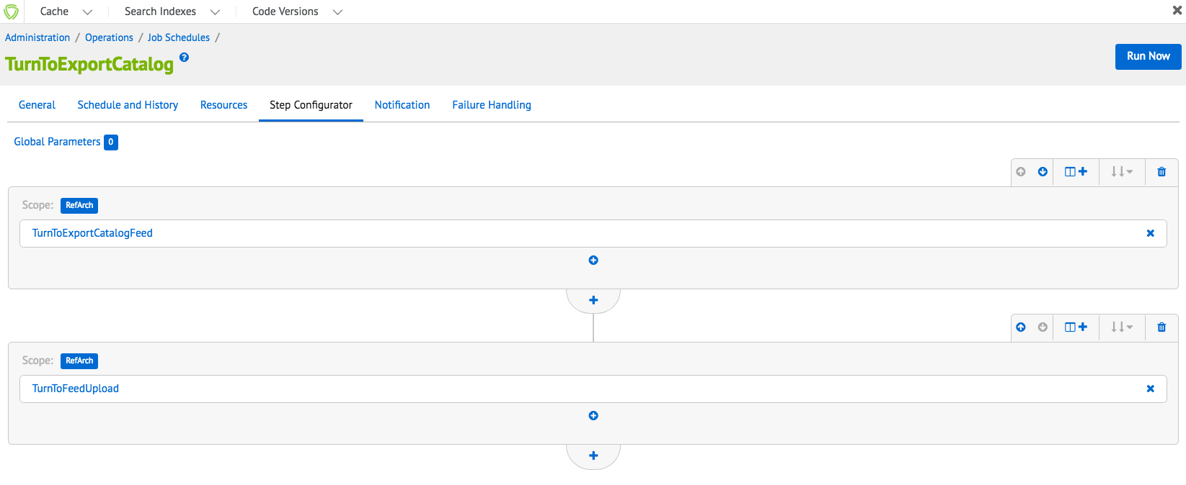

#### TurnTo Historical Order Feed – Ongoing

Purpose: Generates an order feed in the TurnTo format and uploads it to [turnto.com](http://turnto.com/) via HTTP for processing.

The order export feed is localized and may contain multiple feeds if more than one site level locale is enabled.

1. Login to your Business Manager account
2. Click the Site Preferences Link in the Merchant Tools section for your site
3. Click Custom Preferences and then TurnTo Feeds
4. Update the "Historical Order Days" preference to the number of days you want to be exported (typically 2 or 3)
5. Click the Operations link in the Administration section
6. Click Job Schedules
7. Click "TurnToHistoricalOrderExportOngoing”
8. Configure your desired run frequency, as well as any notifications, and make sure "Enabled" is checked
9. Verify the steps in the “Step Configurator” are set to the correct site
10. Click Apply
11. Recommendation: Configure error handling for your email address for testing.

#### TurnTo Historical Order Feed - Specific Date (Optional)

Purpose: Generates an order feed for a specific date in the TurnTo format and uploads it to [turnto.com](http://turnto.com/) via HTTP for processing. This job is meant to be run manually, in the event that orders were skipped by the JS Feed or the Historical Feed - Ongoing.

The specific date order export feed is localized and may contain multiple feeds if more than one site level locale is enabled.

1. Login to your Business Manager account
2. Click the Site Preferences link in the Merchant Tools section for your site
3. Click Custom Preferences and then TurnTo Feeds
4. Update the "Historical Order Date" preference to the specific date you want to export
5. Click the Operations link in the Administration section
6. Click Job Schedules
7. Click "TurnToHistoricalOrderExportSpecificDate"
8. Verify the steps in the “Step Configurator” are set to the correct site
9. Click "Run"
10. Recommendation: Configure error handling for your email address for testing.

#### Multiple Locale Feed Setup

**NOTE: If your site has multiple locales, the feeds can be localized if setup in Business manager and in TurnTo.**

REMINDER: “default” locale is not allowed.

Download (for Reviews and UGC jobs)

1. Contact your TurnTo support representative to enable multiple locales for your TurnTo setup.
2. Each locale will have separate auth and site keys. These keys can be obtained from the TurnTo portal
3. Add the auth and site keys in the Business Manager custom site preference folder “TurnTo General Settings”. See the following screenshot for a sample of the format:

Auth key format

[locale]:[auth_key]

Site key format

[locale]:[site_key]:[domain]

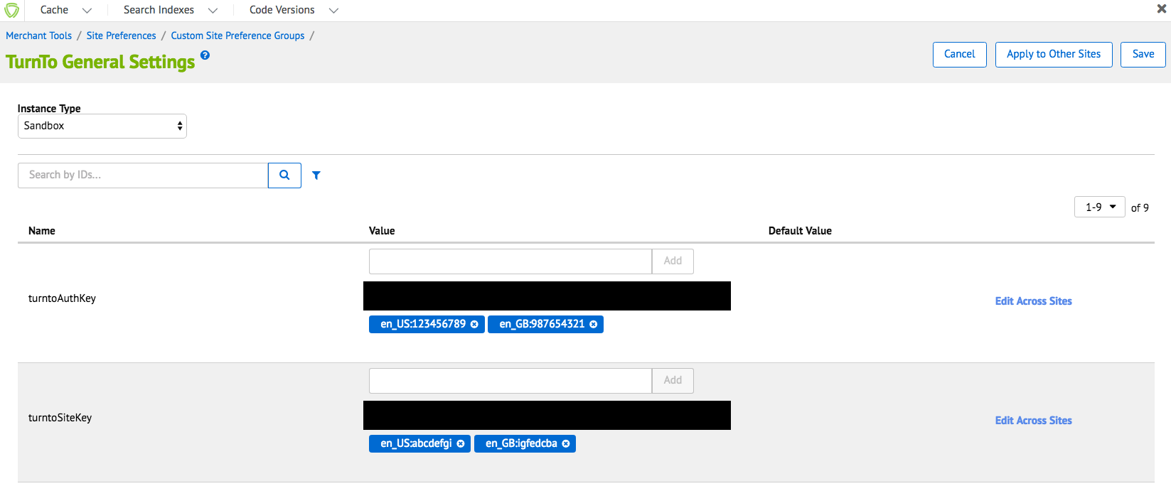

Each download feed URL will contain the unique auth and site keys to distinguish locales.

Download Feed Example (for Reviews and UGC): <http://www.turnto.com/static/export/YOURSITEKEY/YOURAUTHKEY/turnto-ugc.xml>

Upload (for Catalog and Order Export jobs)

**NOTE: The following steps are the same as the previous Download section.**

1. Contact your TurnTo support representative to enable multiple locales for your TurnTo setup.
2. Each locale will have separate auth and site keys. These keys can be obtained from the TurnTo portal
3. Add the auth and site keys in the Business Manager custom site preference folder “TurnTo General Settings”. See the following screenshot for a sample of the format:

Upload Feed Example (for Catalog and Orders exports): <http://www.turnto.com/feedUpload/postfile>

The URL is not unique per locale, instead the content request body will contain multiple HTTP request parts to distinguish the locale using both site and auth keys.

Content HTTP Request parts

1. File -> locale specific file to upload
2. SiteKey -> locale specific site key
3. AuthKey -> locale specific auth key
4. Feed Style -> always the following string “tab-style.1”

#### TurnTo SKU-to-Average Rating Feed (Optional)

Purpose: Downloads and imports the nightly sku-to-average-rating feed for use in the attribute refinements on pages such as search results and category landing

**NOTE: In order to use this job, the steps in “Custom Job Components“ must be completed.**

**NOTE: If your site has multiple locales, the feeds can be localized if setup in Business manager.**

1. Enable the Sku Average Rating Feed Pull in your TurnTo Settings. (Contact your TurnTo support representative to enable.)
2. After the nightly feed is generated, verify that you can access the feed via a browser at: <http://static.www.turnto.com/static/export/YOURSITEKEYHERE/YOURAUTHKEYHERE/turnto-skuaveragerating.xml>
3. Login to your Business Manager account



1. Click the Operations link in the Administration section
2. Click Job Schedules
3. Click "TurnToImportAverageRatings"
4. Configure your desired run frequency, as well as any notifications, and make sure "Enabled" is checked.
5. Verify the steps in the “Step Configurator” are set to the correct site
6. Click Apply
7. After the job has successfully run, products present in the feed will have the following custom attributes populated on the Product record:  
   turntoAverageRating  
   turntoReviewCount  
   turntoRelatedReviewCount  
   turntoCommentCount
8. Recommendation: Configure error handling for your email address for testing.

#### TurnTo User Generated Content Feed (Optional)

Purpose: Downloads and imports the Customer Generated Content XML feed for all products, so that the TurnTo content can be searchable on the storefront or used for SEO.

**NOTE: In order to use this job, the steps in “Custom Job Components“ must be completed.**

**NOTE: If your site has multiple locales, the feeds can be localized if setup in Business manager.**

1. Contact your TurnTo support representative to enable the XML version of the sitewide Customer Generated Content Feed.
2. After the nightly feed is generated, verify that you can access the feed via a browser at: <http://static.www.turnto.com/static/export/YOURSITEKEYHERE/YOURAUTHKEYHERE/turnto-ugc.xml>
3. Login to your Business Manager account
4. Click the Operations link in the Administration section
5. Click Job Schedules
6. Click "TurnToImportUserGeneratedContent"
7. Configure your desired run frequency, as well as any notifications, and make sure "Enabled" is checked.
8. Verify the steps in the “Step Configurator” are set to the correct site
9. Click Apply
10. After the job has successfully run, products present in the feed will have the following custom attributes populated on the Product record:  
    turntoUserGeneratedContent
11. Recommendation: Configure error handling for your email address for testing.

#### Widgets

##### **IMPORTANT NOTE: For SpeedFlex the features are enabled via the TurnTo dashboard and will be sent via the widgets JS file. There is however some coding setup that will be required for certain features (i.e. primarily div element placement).**

**NOTE: The widgets below (except the teasers) use the turnto.js file to obtain and render the HTML and content for features.**

#### Teaser

A teaser is a condensed version of the reviews summary and list content and contains a diverse amount of content

**NOTE: Teasers are the only content that do not use the turnto.js code, the HTML and logic is contained within the teasers.js file**

**NOTE: feature can be enabled/disabled via custom preference in SFCC Business Manager**

**NOTE: Teasers require a minimum of 4 reviews to show the read comments section. This can be modified in the teasers.js file.**

You can include the following information in your CGC Teaser implementation:

* Ratings & Reviews
  + The average Star Rating for this product
  + How many reviews have been published
* Questions & Answers
  + How many questions have been published for this product
  + How many answered questions have been published for this product
  + How many answers have been published for this product
* Checkout Comments
  + How many Checkout Comments have been published

##### Implementation Example

This section walks you through an example implementation using simple JavaScript, CSS, and HTML markup.

Here’s what the example implementation will display on product display pages with both Reviews and Checkout Comments: 

On pages with Checkout Comments but no Reviews:



On pages with Reviews but no Comments (or you choose to exclude Comments from the Teaser): 

Or on pages with no Reviews or Comments (or you choose to exclude Comments from the Teaser):



##### Teaser Stars

**NOTE: The teaser stars are configured by default to use SVGs, see the starsvgs.isml template.**

If you prefer to use images other than SVGs, you’ll need to modify the image reference in the generateTeaserStar and generateTeaserStars functions below.

Other web image formats include the following, JPG, PNG, GIF, etc.

#### Q&A and Reviews

**NOTE: feature can be enabled/disabled via custom preference in SFCC Business Manager**

#### Review Summary Widget

**NOTE: By default, the reviews list is added to the widgets template along with the reviews list.**

**NOTE: feature can be enabled/disabled via custom preference in SFCC Business Manager**

The Review Summary widget succinctly summarizes your review data on the PDP, showing the following elements:

* Overall Rating count
* Average Overall Rating
* Average Overall Rating star display
* Write a Review button
* Rating distribution display - click to filter the Review List widget by selected star rating
* Summaries of any custom review dimension data (e.g., Value, Fit, etc.)

#### No Rating Display

If there are no ratings to summarize, the displays changes to a one-column call-to-action: 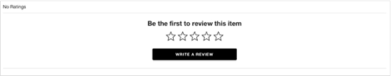

**NOTE: Configuration Options - Virtually all text within the Review Summary widget can be customized. Contact your TurnTo account team to learn more**

#### Review List Widget

**NOTE: By default, the reviews list is added to the widgets template along with the reviews summary.**

**NOTE: feature can be enabled/disabled via custom preference in SFCC Business Manager**

The Review List widget displays a list of shopper Ratings & Reviews for a product. Most customers choose to place the Review List widget directly below the Review Summary widget.

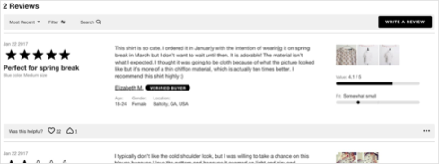

The Review List widget shows the following elements:

* Total review count (‘# Reviews’)
* Sort / Filter bar - only displays if there are 3 or more reviews for a SKU
  + Sort - ability to sort reviews by most helpful, most recent, oldest, highest, and lowest rated
  + Filter Reviews - ability to filter reviews by one or more star ratings
  + Write a Review button - launches Review Submission form
* Review List Items - all published shopper Ratings & Reviews for this product
* Pagination

#### TurnTo Checkout Comments

Features Include:

* Checkout Comments Capture Widget:
* Checkout Comments PDP Widget:
* Checkout Comments Pinboard:
* Checkout Comments Pinboard Teaser:

#### TurnTo Chatter Checkout Comments Display Widget

**NOTE: feature can be enabled/disabled via custom preference in SFCC Business Manager**

Some clients choose to integrate shopper Checkout Comments within the Q&A List widget, such that ‘Why did you choose this?’ is the first question asked, and the comments collected are displayed as the answer:

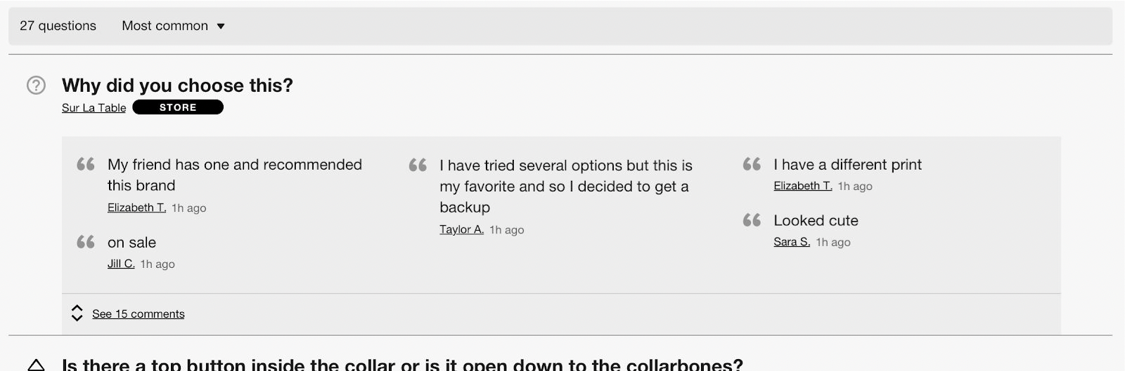

The Comments Display widget offers a popular alternative, displaying comments for a given SKU or product category in a stand-alone widget that can be placed prominently on the product detail page.

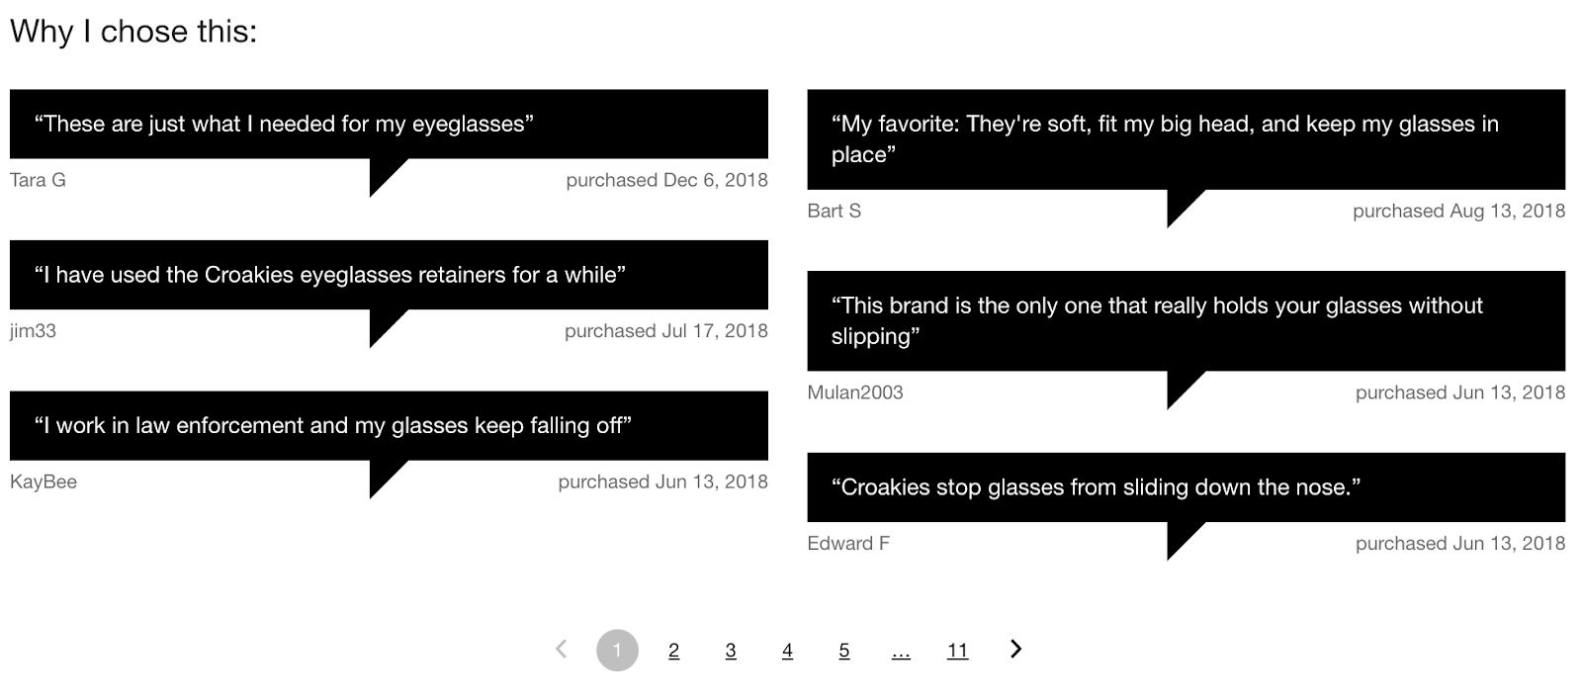

#### TurnTo Top Comment Widget

**NOTE: feature can be enabled/disabled via custom preference in SFCC Business Manager**

The Checkout Comments Top Comment widget returns a single Checkout Comment for each SKU provided. Comments are chosen in order of recency, but the widget can easily be filtered to display only comments with a specific TurnTo Content Tag. This flexible widget promotes customer testimonials on product detail, product listing, and / or custom landing pages.

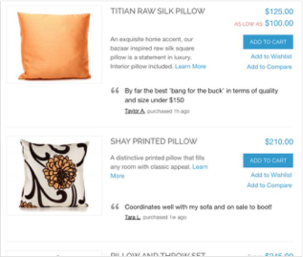 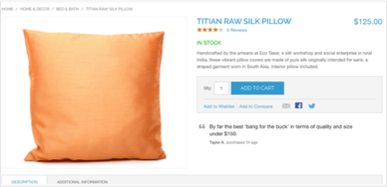

### Set up Search Settings (Optional)

#### Make User Generated Content Searchable

**Purpose: Making the UGC searchable allows for customers to search based on user’s content that is posted on products and it can also be helpful for SEO content.**

**NOTE: The necessary data comes from the User Generated Content Feed.**

1. Login to your Business Manager account
2. Click the Search link under Merchant Tools for your site
3. Click Searchable Attributes
4. Click "New" and add attribute "custom.turntoUserGeneratedContent" to the list, then give it an appropriate Boost Factor
5. Click Apply

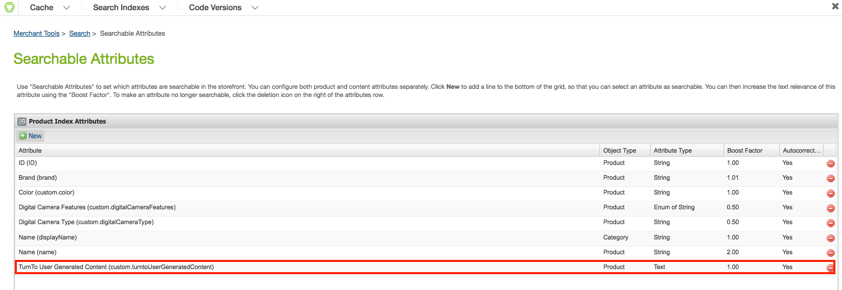

1. Under the Business Manager header, click Search Indexes
2. Check the box for "Product Index" and click Rebuild
3. Now, when you search for specific text that exists in a review, comment, or question, the matching products will show up in the search results.

The following is the result, notice the word “fantastic” is in the UGC attribute and the product shows up in the search.

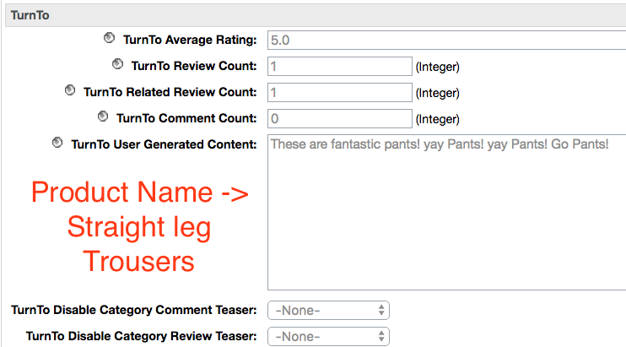

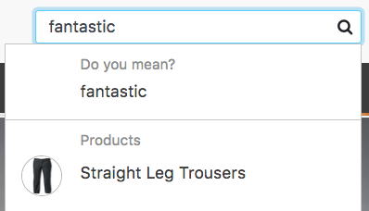

#### 

#### Configure Average Star Ratings as a Search Refinement (Optional)

**NOTE: The necessary data comes from the SKU-to-Average-Rating Feed so this feed must be enabled and run in Business Manager.**

1. Login to your Business Manager account
2. Click the Products and Catalogs link under Merchant Tools for your site
3. Click Catalogs
4. Click the storefront catalog of your site, and then click "Edit" on the top right
5. Click the tab for Search Refinement Definitions, and click "New"

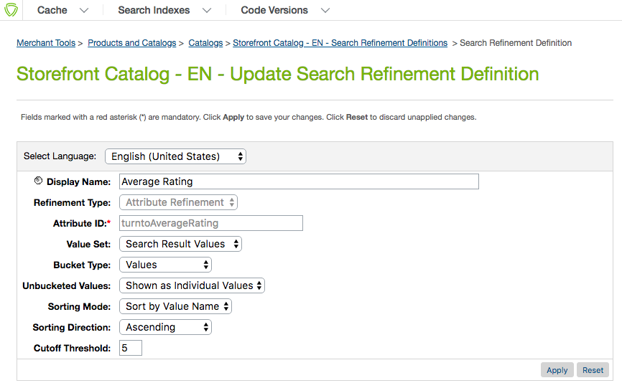

1. Update the following settings:
   1. Display Name: Average Rating
   2. Refinement Type: Attribute Refinement
   3. Attribute ID: turntoAverageRating
   4. Value Set: Search Result Values
   5. Bucket Type: Values
   6. Unbucketed Values: Show as Individual Values
   7. Sorting Mode: Sort by Bucket Position
   8. Sorting Direction: Ascending
   9. Cutoff Threshold: 5
2. Click Apply
3. Under Attribute Bucket Refinements, add the following buckets as shown in the image below:

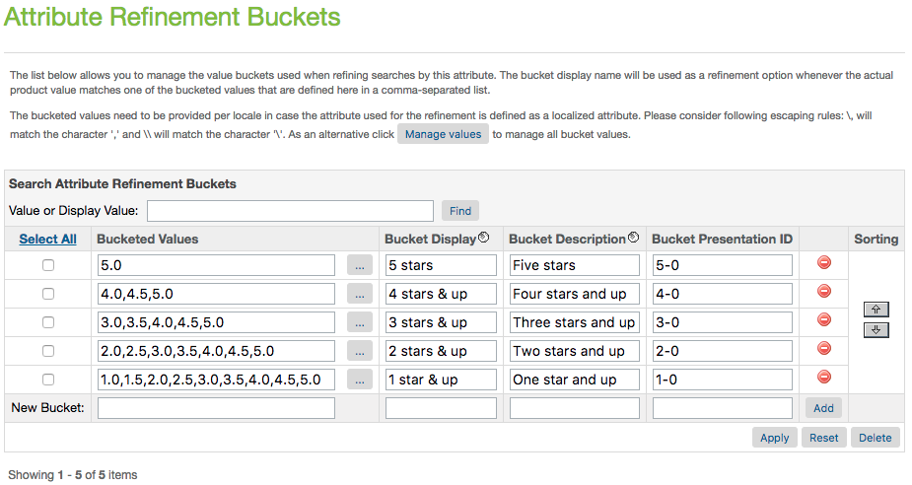

1. Click Apply
2. Under the Business Manager header, click Search Indexes
3. Check the box for "Product Index" and click Rebuild
4. You should now see the refinement for Average Rating on your category and search pages, as seen below:

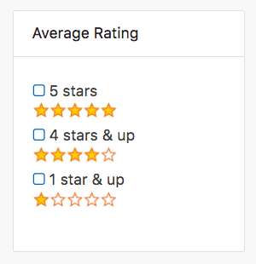

#### Configure Average Star Ratings as a Sortable Filter

**NOTE: The necessary data comes from the SKU-to-Average-Rating Feed.**

1. Login to your Business Manager account
2. Click the Search link under Merchant Tools for your site
3. Click Sorting Rules
4. Click "New" to add a new sorting rule, with the following settings:  
   ID: turnto-ratings  
   Description: Sorts by TurnTo Average Rating
5. With "turnto-ratings" now selected, click Add to add attributes.
6. Select the attribute "TurnTo Average Rating (product.custom.turntoAverageRating), sort direction by "Descending", text relevancy "N/A", and click Apply.

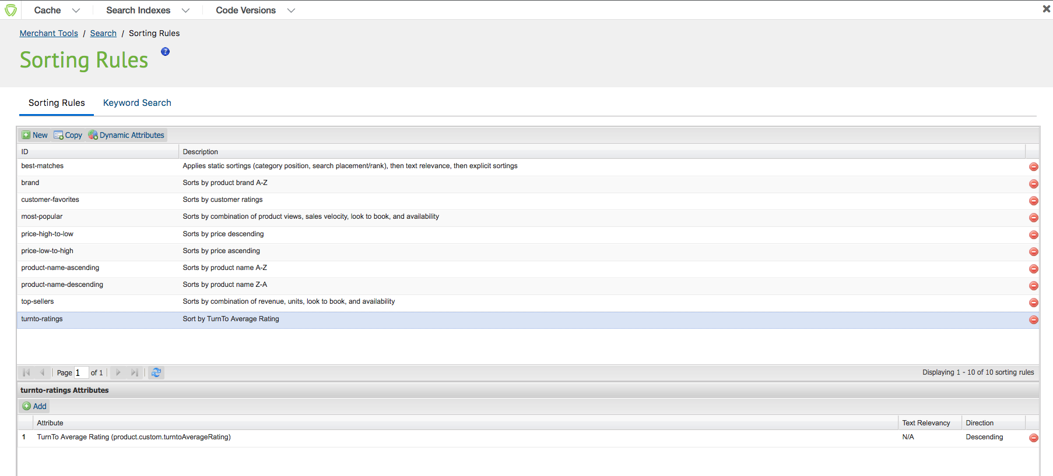

1. Go back to Search, under the Merchant Tools for your site
2. Click Storefront Sorting Options
3. Add a new sorting option, with the following settings:  
   ID: ratings  
   Sorting Rule: turnto-ratings  
   Display Name: Average Rating



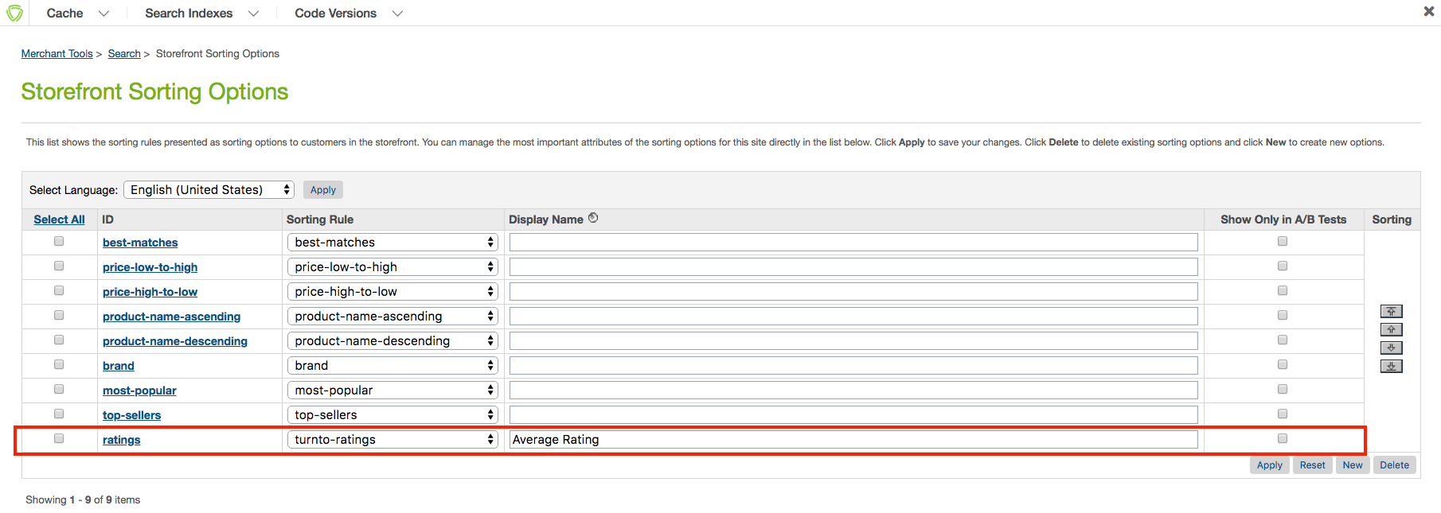

1. Click Apply
2. Under the Business Manager header, click Search Indexes
3. Check the box for "Product Index" and click Rebuild
4. You should now see the refinement for Average Rating on your category and search pages

## Installation & Code

No custom code is necessary as the cartridge overlays with the Site genesis cartridge and implements the necessary templates and controller enhancements for all functionality.

However customization of these templates may be desired or necessary for the integration into storefront overlay cartridges. A listing of the custom templates with descriptions follows. Any and all of these templates may be copied from the cartridge into storefront overlay cartridges for customization (or alternatively used as a reference for storefront customization.

For more information, refer to <http://www.turnto.com/docs> or contact your TurnTo® representative.

### Global Includes

#### TurnToConfig Object

Every page will require a TurnToConfig object, which must have a locale, page ID and TurnToCmd command. The object may or may not have additional attributes.

**NOTE: The TurnToConfig objects are located on the “htmlheadincludejs.isml” template and are pre-configured for pages such as PDP, checkout, confirmation and search results.**

Base TurnToConfig object Example (Not including advanced configurations)

var turnToConfig = {

locale: “en_US”,

pageId: “pdp-page”

}

window.TurnToCmd=window.TurnToCmd||function(){(TurnToCmd.q=TurnToCmd.q||[]).push(arguments)};

<script src=*"https://widgets.turnto.com/v5/widgets/${siteKey}/js/turnto.js"* async></script>

### Product Detail Page

#### Teasers (Q&A, R&R)

The teasers logic relies on a separate JavaScript file, *teasers.js,* which needs to be placed on your site.

**NOTE: The *teasers.js* is not placed in code out of the box and will need to be placed with other include JavaScript files.**

**NOTE: Teasers require a minimum of 4 reviews to show the read comments section. This can be modified in the teasers.js file.**

The PDP reviews summary and list rely on the following two div elements to be placed on the page for the widget JS to properly render the data.

<div id=”tt-reviews-summary”></div>

<div id=”tt-reviews-list”></div>

1. By default, the PDP page will contain the above two DIVs, but will only display data if it exists for the current SKU
2. **NOTE: If a user selects a variant SKU, the TurnTo configuration oibject auto refreshes via the following Javascript function**

TurnToCmd{‘set’, {‘sku’:’newsku’});

1. **NOTE: For now the Reviews Summary and Review List widgets will *not* be reported in TurnTo conversion reporting**.

**NOTE: If you want to place the content underneath a tab, you will need to do the following.**

Add a click event listener to the link. In this example, it assumes there is a function on the page that can be called to expose a tab called ‘showTab’. Change this to whatever function is available on the page to accomplish this. This code should be added to the end of the ‘populateTeaser’ function.

document.querySelector(‘.TTteaser__read-reviews’).addEventListener(‘click’, function(e) { showTab(‘reviews’); }

#### Widgets (Q&A, R&R, Checkout Comments)

1. Product sets have the widgets too, but if you want to change the location of code, see the following template
   1. *templates/default/product/producttopcontentPS.isml*

### Category and Search Pages

#### Refinements (optional)

**NOTE: You will need to have completed the "Configure Average Star Ratings as a Search Refinement" steps under "Configuration" for the refinements to show up.**

#### Product Tile Teaser (optional)

**NOTE: In SpeedFlex, product teasers are not supported for multiple SKU pages**

#### Checkout Comments Pinboard Teaser (optional)

The CC Pinboard rely on the following div element to be placed on the page for the widget JS to properly render the data.

**NOTE: By default this div element is placed on the turntopinboard template and included on the following three templates: *homepage.isml, catlanding.isml* and *categoryproducthits.isml***

<div id=”tt-comments-pinboard”></div>

1. A few things to note about the CC Pinboard Teaser:
   1. For ALL pages, the teaser will only show if there are at least 4 products that have 4 buyer comments each (**Default configuration)**
   2. On the home page, or a page without a pdict.category all products sitewide will be considered for display
   3. On a category page, only the products that belong to that category (defined in the Catalog Feed) will be considered for display
   4. On a category page, only the categories that have the custom attribute turntoEnableCCPinboardTeaser set to true will render the teaser.

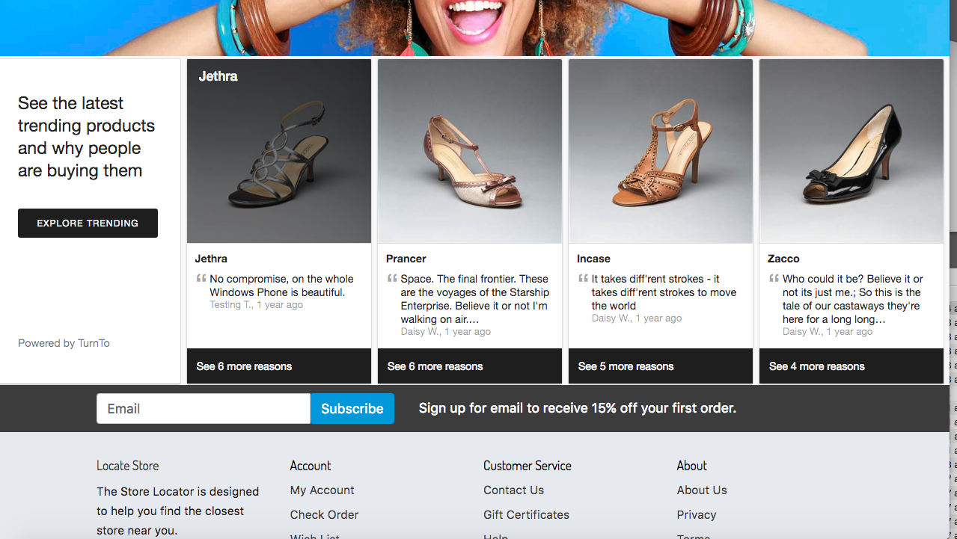

##### Advanced Configuration Options

**NOTE: These settings are not configured within the SFCC code. Please modify them in the TurnTo dashboard**

|  |  |  |
| --- | --- | --- |
| Option | Default Setting | Description |
| variant div IDs | tt-comments-pi nboard-widget | You may specify a different div ID if you wish. |
| activeOnly | true | If true will only return content for active products |
| includeSyndicated | false | Whether syndicated comments should display within widget |
| maxDaysOld | 30 | The maximum days old a comment can be and still appear in the product box.  A value of -1means all comments should be included, regardless of age |
| limit | 20 | The maximum number of product boxes to be displayed on page load.  The remaining product boxes will be loaded in batches equal to the limit |
| progressiveLoading | true | When set to 'true' any remaining available content beyond the set limit  will load once the user gets to the bottom of the page. If set to ‘false’ a  ‘load more’ button will display instead. |
| showReviewStars | false | Displays review stars (if available) below product title on image mouseover |
| maxCommentsPerBox | 5 | The maximum number of comments that should be displayed in each product box |
| titleMaxLength | 255 | The maximum length of the product title, after which displays an ellipsis (...) |
| hoverTitleMaxLength | 65 | The maximum length of the product title which displays on mouse hover,  after which displays an ellipsis (...) |
| commentMaxLength | 200 | The maximum length of text characters to display. ends with ellipsis (...) |
| nameMaxLength | 255 | The maximum length of the user’s name, after which displays an ellipsis (...) |

### Other Features

#### Javascript Order Feed

**NOTE: During the integration process clients typically provide TurnTo with a one-time historical order feed that populates the TurnTo system with past order data. Once TurnTo is live, the JavaScript Order feed passes newly placed orders from the order confirmation page to the TurnTo system.**

**NOTE: We recommend adding this JavaScript code on your production site prior to going live so you can start to build your product owner pools early on.**

The order feed code has already been placed in the cartridge. See the following template ***confirmationinclude.isml***

Order Data Fields

|  |  |  |
| --- | --- | --- |
| Name | Required? | Description |
| orderId | Y | The id of the order |
| email | Y | Customer email address |
| firstName | Y | Customer first name |
| lastName | Y | Customer last name  *Note: I* *f 'firstName' and 'lastName' are not*  *present the JS Feed, we take the first letter*  *of the email as first name and the second*  *letter as last name.* |
| nickName | N | The nickname of the customer |
| postalCode | N | Postal code |
| deliveryDate | N | The date by which the  purchased item will be delivered  to the customer. Value should be a  string in 'yyyy-MM-dd' format.  (e.g. '2019-02-23' for February 23, 2019). |
| emailOptOut | N | Default value ‘false’. Set to the  boolean value 'true' if shopper  should receive no emails from TurnTo. |
| items | Y | An array containing data about  each line item in the order (see  ‘Line Item Fields’ below for a list  of objects in the items array) |

Line Item Fields

|  |  |  |
| --- | --- | --- |
| Name | Required? | Description |
| SKU | Y | The SKU of the product |
| title | N | The product name. We strongly recommend that you include this field to avoid errors if the purchased SKU isn't present in your catalog feed. The value passed will never overwrite the catalog feed data for the given SKU. |
| url | N | The product URL on your site. We strongly recommend that clients include this field to avoid errors if the purchased SKU isn't present in your catalog feed. The value passed will never overwrite catalog feed data for the given SKU. |
| itemImageUrl | N | The image URL for the product. We strongly recommend that clients include this field to avoid errors if the purchased SKU isn't present in your catalog feed. The value passed will never overwrite catalog feed data for the given SKU. |
| price | N | The price of the product. The value passed will never overwrite catalog feed data for the given SKU (only used if the purchased SKU wasn't included in your catalog feed). |
| lineItemId | N | The line item id of the order |
| siteKey | Only required for multi-store clients | The TurnTo Site Key of the store where the item was added to the cart |

#### Checkout Comments Capture Widget

**NOTE: To install the Comment Capture widget you must also install the JavaScript Order feed on your order confirmation page, which is added to the cartridge out of the box, see *confirmationinclude.isml***

The order feed code has been added as stated above, however the comment capture div has not been added and will need to be added to any pages you would like the widget to display on.

<div id=”tt-comment-capture”></div>

##### Advanced Configuration Options

**NOTE: These settings are not configured within the SFCC code. Please modify them in the TurnTo dashboard**

|  |  |  |
| --- | --- | --- |
| Option | Default Setting | Description |
| variant div IDs | tt-comment-cap ture | You may specify a different div ID  if you wish. |
| embed | false | Enables the *embedded* Comment  Capture display option |
| paginate | false | Enables the *paginated*  one-item-per-card experience |
| showUsername | true | Whether or not to display the  shopper’s name and purchased  timestamp below the comment  submission field |
| delayDisplaySeconds | 3 | The number of seconds to wait  before displaying the comment  capture *overlay* |

#### Chatter Checkout Comments Display Widget

The chatter widget requires modification to the turnToConfig object for the page(s) you wish for the widget to be displayed on.

The following shows the chatter attribute of the turnToConfig object.

**NOTE: please note that the following is a sample only.**

<script>

var turnToConfig = {

sku: “YOUR PRODUCT SKU GOES HERE”,

locale: “en_US”,

pageId: “pdp-page”,

chatter: {

//onFinish: function() {}

}

}

</script>

The onFinish attribute is an optional property within turnToConfig that can be used to trigger an event record in your analytics package after the widget has finished loading.

The widget div must then be placed anywhere you would like it.

**NOTE: By default the div is not placed anywhere out of the box, but it is contained within the *turntochatter.isml* template.**

<div id=”tt-chatter-widget”></div>

##### **Important Notes:**

* **The CC Display widget does *not* support multiple SKUs; only one product or category SKU is accepted.**
* **If the SKU passed is a VPC parent or child, then the widget will pull in comments for all sibling SKUs automatically. There is no configuration option to turn this feature on or off.**
* **The CC Display widget is not currently filterable by content tag.**

**NOTE: The CC display widget requires a minimum of 4 comments in order for the widget to appear.**

##### Advanced Configuration Options

**NOTE: These settings are not configured within the SFCC code. Please modify them in the TurnTo dashboard**

|  |  |  |
| --- | --- | --- |
| Option | Default Setting | Description |
| variant div IDs | tt-chatter-widget | You may specify a different div ID if you wish. |
| minCount | 4 | Minimum number of comments required for the widget to display |
| widget title | Why I chose this: | Title text that displays within the widget above the comments |
| includeSyndicated | false | Whether syndicated comments should display within the widget |
| minCharacterCount | 20 | Comments with fewer characters than this minimum will not be included in widget counts or display |
| minWordCount | 3 | Comments with fewer words than this minimum will not be included in widget counts or display |
| limit | 6 | The maximum number of comments to be displayed on page load. The remaining product boxes will be paginated in batches equal to the limit |
| Number of columns, spacing by breakpoint | see description | The number of columns to display and horizontal and vertical spacing by viewport size |
| sortOrder | most recent | Order display of comments by most recent or by highest character count |
| truncateLength | 200 | The maximum length of text characters to display. ends with ellipsis (...) |
| truncateAllowance | 9 | If the comment character count falls between the truncateLength and truncateAllowance, then the full comment is displayed and it will not be truncated |

#### Top Comment Widget

The top comment widget requires modification to the turnToConfig object for the page(s) you wish for the widget to be displayed on.

The following shows the top comments attribute of the turnToConfig object.

**NOTE: please note that the following is a sample only.**

<script>

var turnToConfig = {

locale: “en_US”,

pageId: “pdp-page”,

topComments: {

//tags: [],

//onFinish: function() {}

}

}

</script>

The tags attribute is an optional property within turnToConfig that allows you to filter displayed content by one or more tag code(s). The parameter must be set as an array, e.g. tags: ['tagcode1','tagcode2'].

The onFinish attribute is an optional property within turnToConfig that can be used to trigger an event record in your analytics package after the widget has finished loading.

The widget div must then be placed anywhere you would like it.

**NOTE: By default the div is not placed anywhere out of the box, but it is contained within the *turntotopcomment.isml* template.**

<div id=”tt-top-comment” data-ttsku=”YOUR SKU GOES HERE”></div>

Use the built-in widget refresh function if you are implementing the Top Comment widget on a page that dynamically loads additional content when shoppers interact with the page, e.g., by clicking a ‘Load More’ link or scrolling to the bottom of the page.

**NOTE: the widget refresh logic is not added out of the box**

TurnToCmd(‘topComments.process’)

After calling this function, the widget will be updated with content that applies to the additional SKU(s).

##### Advanced Configuration Options

**NOTE: These settings are not configured within the SFCC code. Please modify them in the TurnTo dashboard**

|  |  |  |
| --- | --- | --- |
| Option | Default Setting | Description |
| variant div IDs | tt-top-comment | You may specify a different div ID if you wish. |
| title | *empty* | Allows you to prepend text before the checkout comment to give it context. Here’s an example where title is set to ‘Why:’:  **Why:** “These are the only ones that work for me. Love them!” |
| includeSyndicated | false | Whether syndicated comments should display within the widget |
| minCharacterCount | 20 | Comments with fewer characters than this minimum will not be included in the widget |
| minWordCount | 3 | Comments with fewer words than this minimum will not be included in the widget |
| truncateLength | 200 | The maximum length of text characters to display. ends with ellipsis (...) |
| truncateAllowance | 9 | If the comment character count falls between the truncateLength and truncateAllowance, then the full comment is displayed and it will not be truncated |

## Testing Use Cases

**IMPORTANT NOTE: Features are enabled via the TurnTo dashboard and not site preferences as in v4.3 and older. Please refer to your TurnTo contact to enable these features.**

### Q&A Testing

**IMPORTANT NOTE: The reviews summary will only show up if there are reviews or questions on the product SKU.**

1. Navigate to any product page and scroll near the bottom to see the Q&A module working:
2. Refresh the PDP page and see the updated data delivered dynamically from TurnTo:

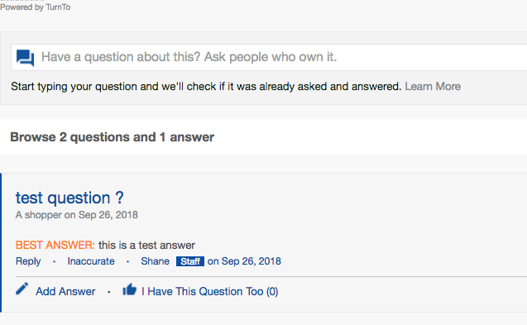

### Reviews Testing

**IMPORTANT NOTE: The reviews summary will only show up if there are reviews or questions on the product SKU.**

1. Navigate to the PDP and observe the teaser and review widget on the PDP:

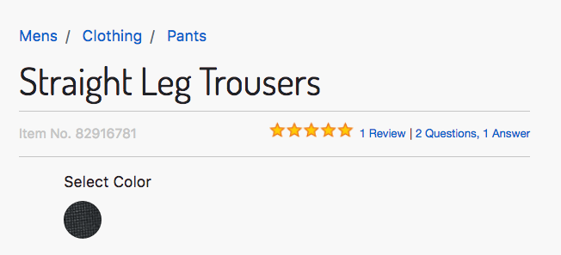

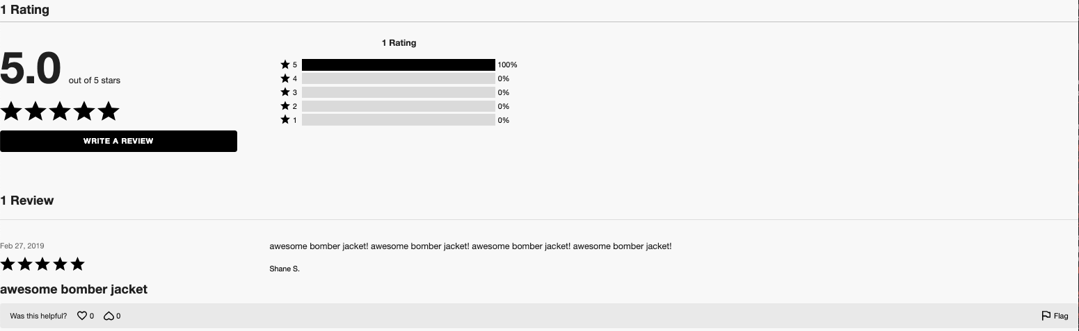

1. Click on Write a Review and populate some data:

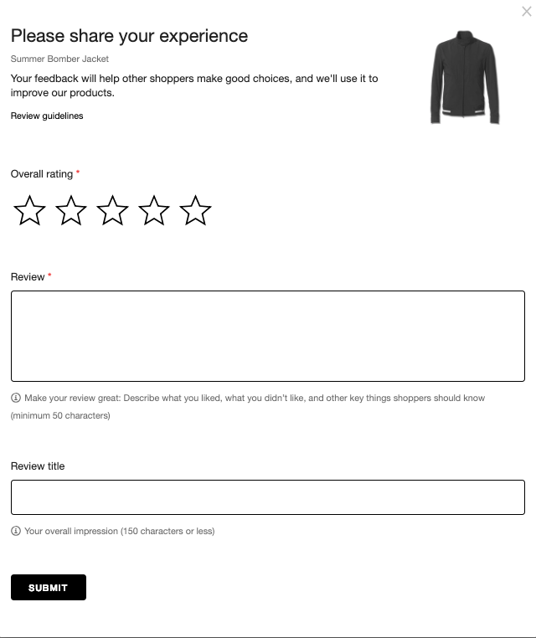

1. After the review has been moderated in the TurnTo dashboard, the review will appear on the PDP.



### 

### Refinements Testing

1. Follow the guide steps in “Configure Average Star Ratings as a Search Refinement” to enable the TurnTo average rating for desired storefront catalog refinements. After setup you will see the following on search and category results page if one or more product(s) have at least one review.

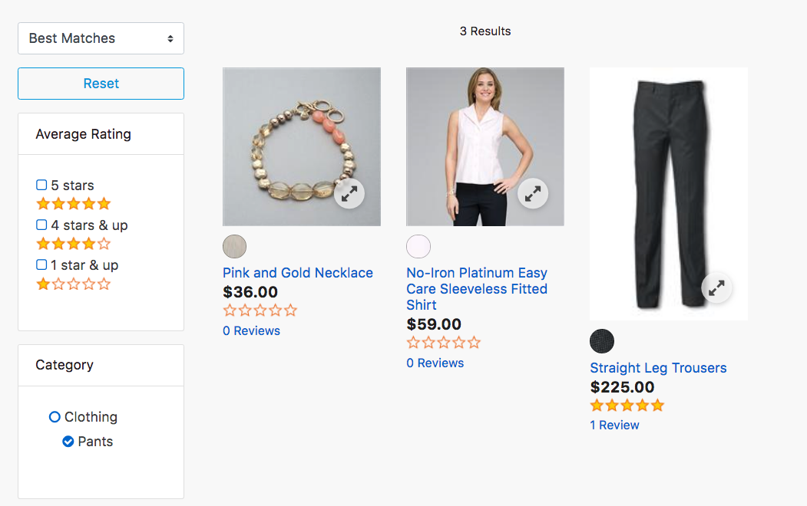

### Checkout Comments

1. Place an order on the storefront and observe the checkout comments module:

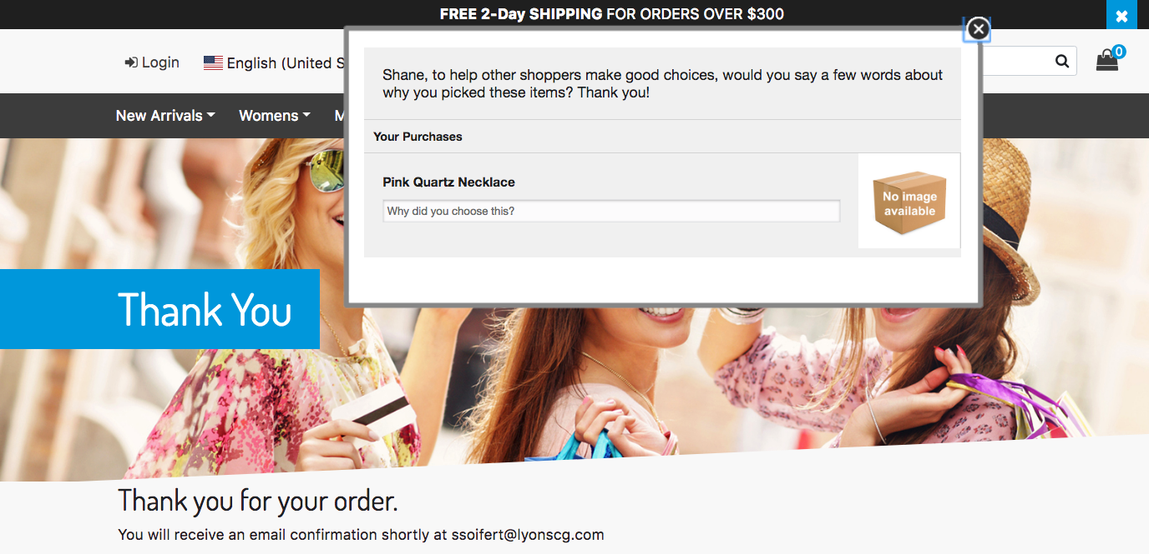

To test any of the specific other checkout comment features (category page, etc) see the installation guide above for the necessary criteria.

### Javascript Order Feed Testing

1. Create a mock order on your order confirmation page.
2. Visit the page with Chrome Web Developer Tools (or Firebug from Firefox) open to the  ‘Console’ tab.
3. Note any turnto.js errors that you may find. Specifically those that start with “TurnTo:  (error) order feed - “.
4. Search for ttreqid call (example 'en_US?ttreqid=1234...') and click on the 2nd one. The  Request Method should be POST, not OPTIONS.
5. Scroll to the bottom of the 'Headers' pane in the 'Request Payload' section to see and  confirm that the correct order data is being passed.
6. If there are errors in the Javascript Order Feed or you need further assistance with troubleshooting please contact your TurnTo account team at support@turnto.com .